ASSIGNMENT 5

Q.1 Objective: Configure Static Route in Cisco packet tracer
• Static route tells the device exactly where to send traffic, no matter what.
• Static route is often used when your network has only a few routers or there is only one
route from a source to a destination.

1.Networks:
- Left LAN: 192.168.1.0/24
- Right LAN: 192.168.2.0/24
- Between routers: 10.0.0.0/30
2. Configure IP on Routers
🔹 R1
enable
configure terminal
interface fastethernet 0/0
ip address 192.168.1.1 255.255.255.0
no shutdown
interface serial 0/0/0
ip address 10.0.0.1 255.255.255.252
no shutdown
exit
🔹 R2
enable
configure terminal
interface fastethernet 0/0
ip address 192.168.2.1 255.255.255.0
no shutdown
interface serial 0/0/0
ip address 10.0.0.2 255.255.255.252
no shutdown
exit
3. Configure Static Routes (MAIN PART)
On R1:
ip route 192.168.2.0 255.255.255.0 10.0.0.2
On R2:
ip route 192.168.1.0 255.255.255.0 10.0.0.1
4. Configure PCs
PC1:
ip 192.168.1.2 255.255.255.0
gateway 192.168.1.1
PC2:
ip 192.168.2.2 255.255.255.0
gateway 192.168.2.1
5. Test
From PC1:
ping 192.168.2.2
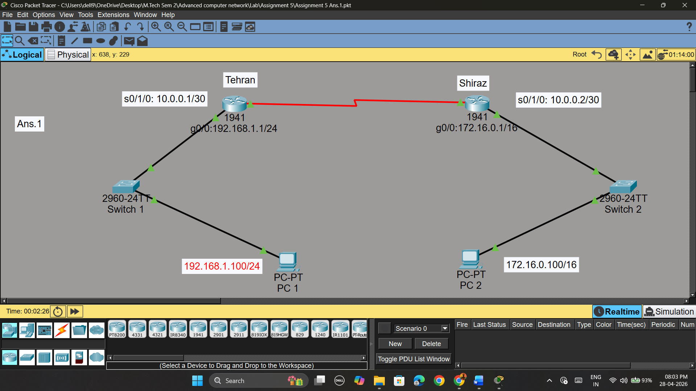

Q.2 Suppose you want to create 3 subnets of a network having network address
198.168.1.0. In another network with network address 220.168.2.0, you want to
create 2 subnets. For this scenario configure the end devices and routers
accordingly. Connect two different networks (both are subnetted) through static
routing and show the message transmission among hosts of the two networks

1. Subnetting
🔹 Network 1: 198.168.1.0 → need 3 subnets
Borrow 2 bits → /26 (255.255.255.192) → gives 4 subnets
Subnets:
- 198.168.1.0/26
- 198.168.1.64/26
- 198.168.1.128/26
🔹 Network 2: 220.168.2.0 → need 2 subnets
Borrow 1 bit → /25 (255.255.255.128)
Subnets:
- 220.168.2.0/25
- 220.168.2.128/25
2. Topology
- R1 → handles 3 subnets (Network 1)
- R2 → handles 2 subnets (Network 2)
- R1 ↔ R2 connected via serial link
3. Router Configuration
🔹 R1 (3 subnets side)
enable
configure terminal
interface fastethernet 0/0
ip address 198.168.1.1 255.255.255.192
no shutdown
interface fastethernet 0/1
ip address 198.168.1.65 255.255.255.192
no shutdown
interface fastethernet 1/0
ip address 198.168.1.129 255.255.255.192
no shutdown
interface serial 0/0/0
ip address 10.0.0.1 255.255.255.252
no shutdown
exit
🔹 R2 (2 subnets side)
enable
configure terminal
interface fastethernet 0/0
ip address 220.168.2.1 255.255.255.128
no shutdown
interface fastethernet 0/1
ip address 220.168.2.129 255.255.255.128
no shutdown
interface serial 0/0/0
ip address 10.0.0.2 255.255.255.252
no shutdown
exit
👉 If DCE side:
clock rate 64000
4. Static Routing (IMPORTANT)
On R1:
ip route 220.168.2.0 255.255.255.128 10.0.0.2
ip route 220.168.2.128 255.255.255.128 10.0.0.2
On R2:
ip route 198.168.1.0 255.255.255.192 10.0.0.1
ip route 198.168.1.64 255.255.255.192 10.0.0.1
ip route 198.168.1.128 255.255.255.192 10.0.0.1
5. Configure End Devices
Example PCs:
Network 1:
- PC1 → 198.168.1.2 /26, GW 198.168.1.1
- PC2 → 198.168.1.66 /26, GW 198.168.1.65
- PC3 → 198.168.1.130 /26, GW 198.168.1.129
Network 2:
- PC4 → 220.168.2.2 /25, GW 220.168.2.1
- PC5 → 220.168.2.130 /25, GW 220.168.2.129
6. Test Communication
From any PC (e.g., PC1):
ping 220.168.2.2
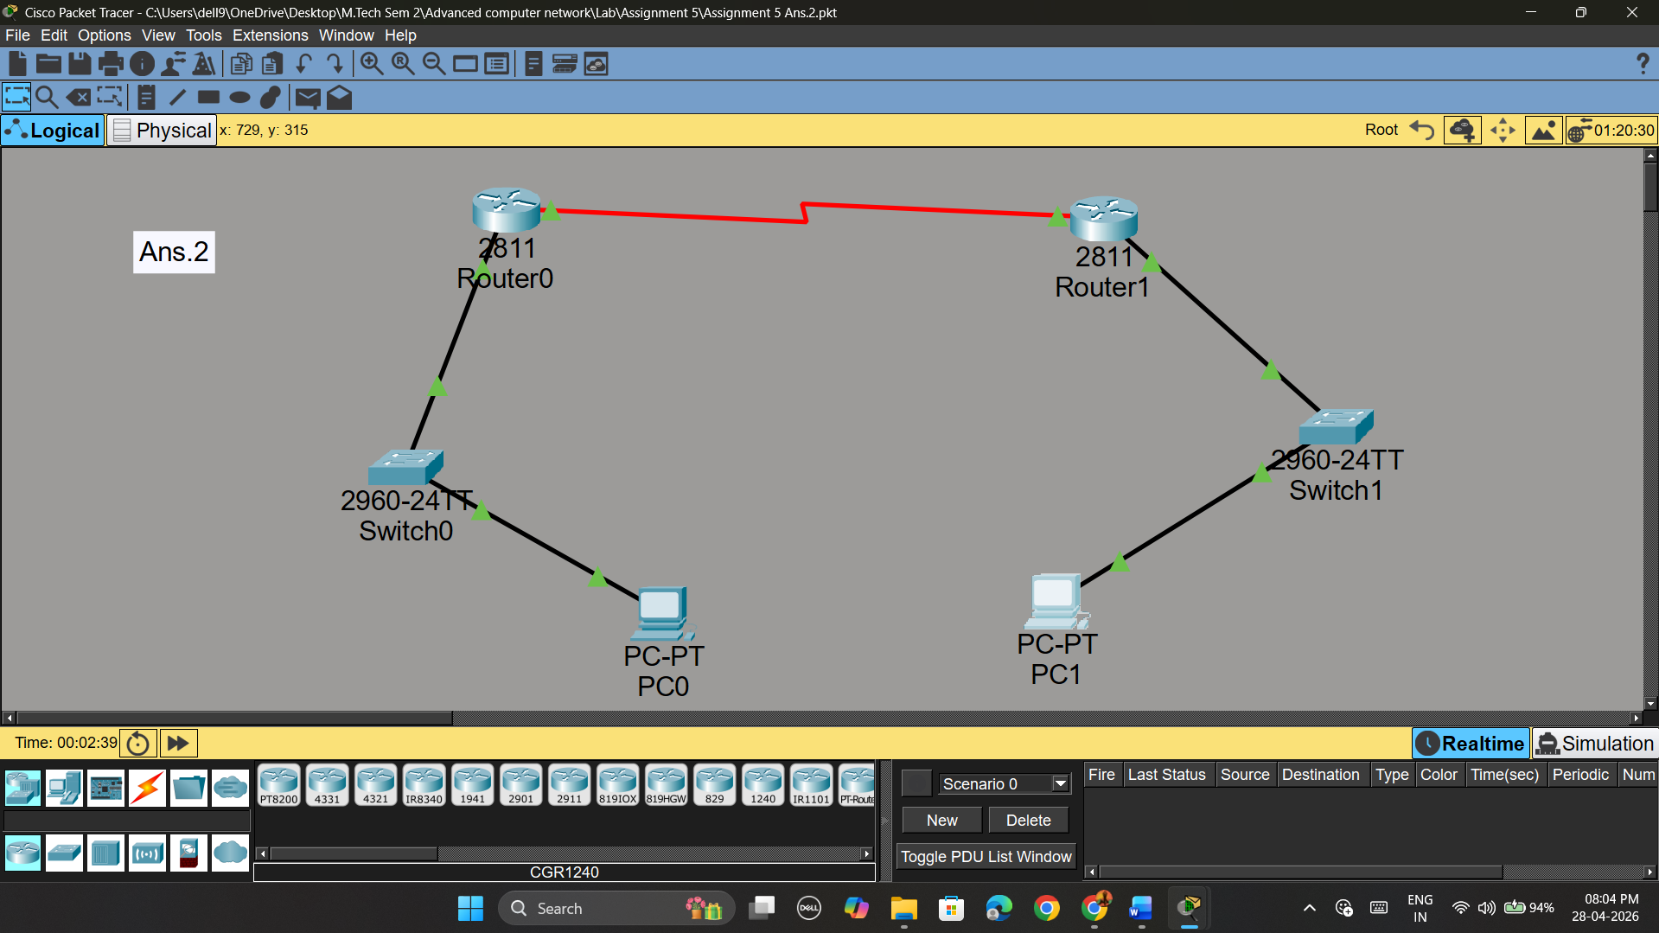

Q.3. Connect two networks having network address 192.168.3.0 and 224.152.1.0
respectively. Network 1 having 4 and network two having 3 hosts. Connect two
different networks through a router. For this scenario configure the end devices
and routers accordingly and show the message transmission among hosts of the
two networks.

1. Network Planning
You have:
- Network 1: 192.168.3.0 (4 hosts needed)
- Network 2: 224.152.1.0 (3 hosts needed)
Minimum subnet for both = /29 (255.255.255.248)
- Gives 6 usable IPs (enough for 4 and 3 hosts)

2. Router Configuration
Go to Router CLI:
enable
configure terminal
! Network 1 interface
interface fastethernet 0/0
ip address 192.168.3.1 255.255.255.248
no shutdown
! Network 2 interface
interface fastethernet 0/1
ip address 224.152.1.1 255.255.255.248
no shutdown
exit

3. Configure End Devices

🔹 Network 1 PCs (4 hosts)
PC1: ip 192.168.3.2 255.255.255.248
gateway 192.168.3.1
PC2: ip 192.168.3.3 255.255.255.248
gateway 192.168.3.1
PC3: ip 192.168.3.4 255.255.255.248
gateway 192.168.3.1
PC4: ip 192.168.3.5 255.255.255.248
gateway 192.168.3.1

🔹 Network 2 PCs (3 hosts)
PC5: ip 224.152.1.2 255.255.255.248
gateway 224.152.1.1
PC6: ip 224.152.1.3 255.255.255.248
gateway 224.152.1.1
PC7: ip 224.152.1.4 255.255.255.248
gateway 224.152.1.1

4. Test Communication
From any PC (example PC1):
ping 224.152.1.2

